|  |
| --- |
| *VENI App* |
| **System Architecture Document** |
| **SE 6387 Advanced Software Engineering Project**  **R.Z. Wenkstern**    ***April 22, 2015*** |

|  |
| --- |
| **Group *X*** |
| **Brian MacKay** |
| **Anant Kambli** |
| **Raleigh Murráy** |
| **Shahed Shuman** |
| **Kathryn Whitmire** |

**Revision History**

|  |  |  |  |
| --- | --- | --- | --- |
| **Version** | **Date** | **Description** | **Authors** |
| 1.0 | 21-Mar-2015 | Created initial document | K.Whitmire |
| 1.0 | 22-Apr-2015 | Date correction | K.Whitmire |

Contents

High level design diagrams 4

High level design 4

Component Diagram 5

Layer Diagram 6

Class Diagram 7

# High level design diagrams

## High level design

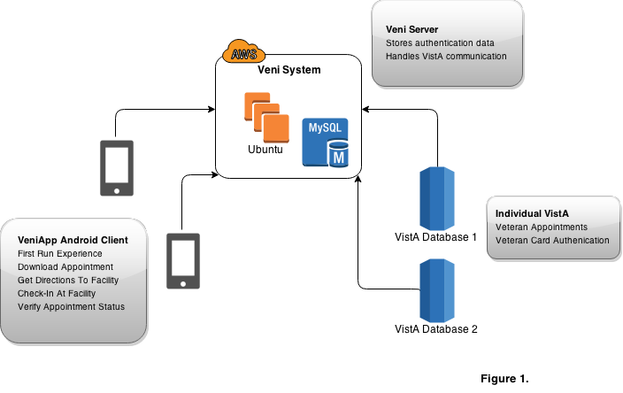

Figure 1

## Component Diagram

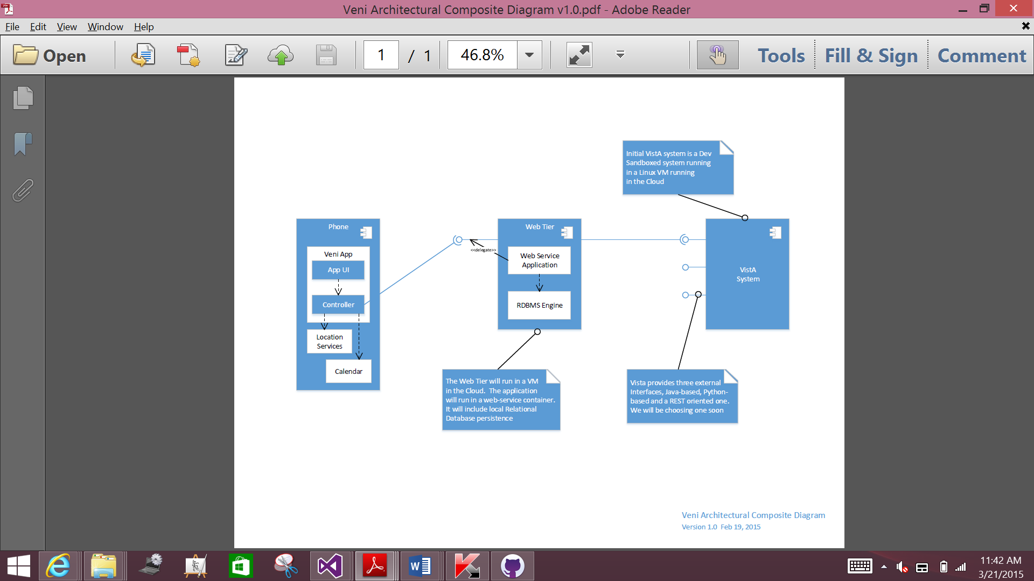

Figure 2

## Layer Diagram

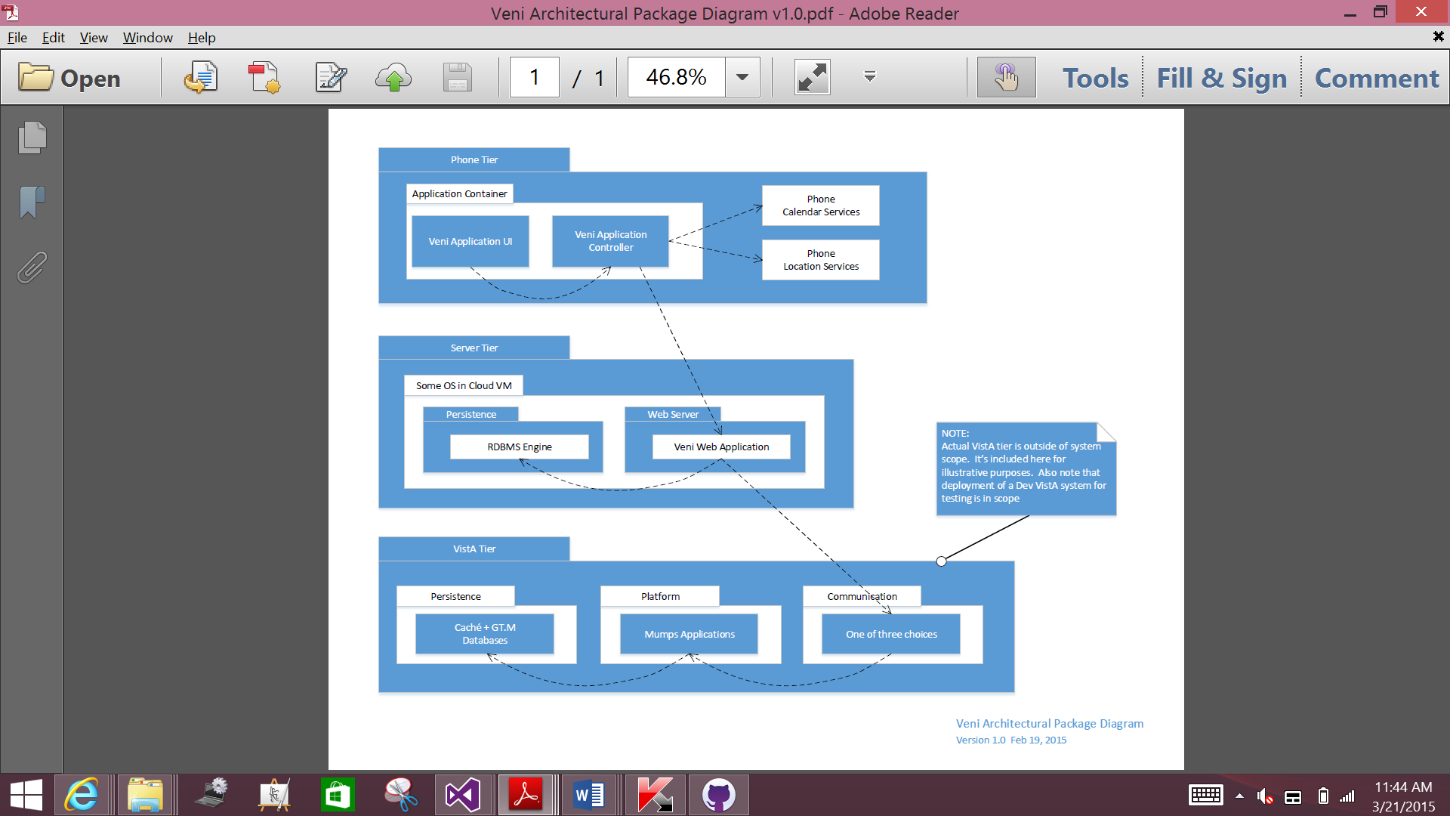

Figure 3

## Class Diagram

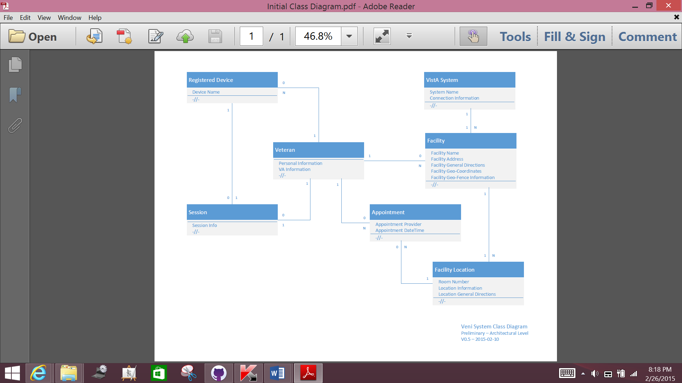

Figure 4